Catania Chiropractic
Dr. Paul Catania
320 Dundas St.
London, ON N6B 3R8

Name:
Address : City: Postal Code:
Home Phone: Business Phone: Cellular:
Email:
By providing your e-mail you consent to e-mail reminders for appointments and notices regarding special notices that affect my care from Catania Chiropractic.
_____/______/______
DD MM Y Y
Date of Birth: Gender: Male Female Marital Status: Single Married Divorced Widow
Number of Children: Occupation: Employer :
Have you ever had previous chiropractic care? Yes No With who?
Who referred you to our office?

State your primary complaint and/or concern:

When did it first start? Have you had it in the past? Yes, if so when No
What makes it worse?

What makes it better?

Describe how it feels?
sharp dull achy throbbing numb tingling burning
stiff other(please explain)
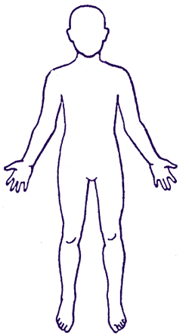
Please circle the location of your complaint:
My condition is localized to a specific area
Or
It radiates to other parts of body, explain:

Is this condition: constant comes and goes getting worse with time

Systems Analysis
Eyes, Ears, Nose & Throat
Earache/Infections
Deafness
Ringing in ears
Sinus trouble
Allergies
Vision problems

Muscle and Joint
Backache
Neck pain
Hernia
Spinal curvature
Poor posture
Painful Tailbone

Gastro-Intestinal
Difficult digestion
Belching or gas
Nausea
Vomiting
Constipation
Diarrhea
Liver Trouble
Gall bladder trouble
Food sensitivity/allergy

General
Allergy
Loss of balance
Fainting
Diabetes
Skin problems
Hyperactivity

Please indicate any medications you are presently taking:

Please list any significant illness, operations, accidents, falls or traumas:

Date signed
Signature
Other:

Personal Stress Levels
Past Present
High
Moderate
Light
None

Cardiovascular
Rapid heart beat
Slow heart beat
High blood pressure
Low blood pressure
Poor circulation
Swelling of ankles
Previous heart attack
Previous stroke

Urinary
Painful urination
Bed-wetting
Frequent urination
Blood in urine
Stress Symptoms
Headaches
Migraines
Loss of sleep
Loss of concentration
Irritable/nervousness
Depression
Decreased energy
Tension
Women Only
Painful menstruation
Excessive flow
Irregular
Abnormal discharge
Birth control pill
Previous miscarriage
Menopausal

Respiratory
Chronic cough
Spitting up phlegm
Spitting up blood
Chest pain
Asthma
Emphysema
Bronchitis
Croup

Dr. Paul Catania 320 Dundas St Unit 6 London ON N6B 3R8
Dr. Paul Catania 320 Dundas St. Unit 6 London On N6B3R8 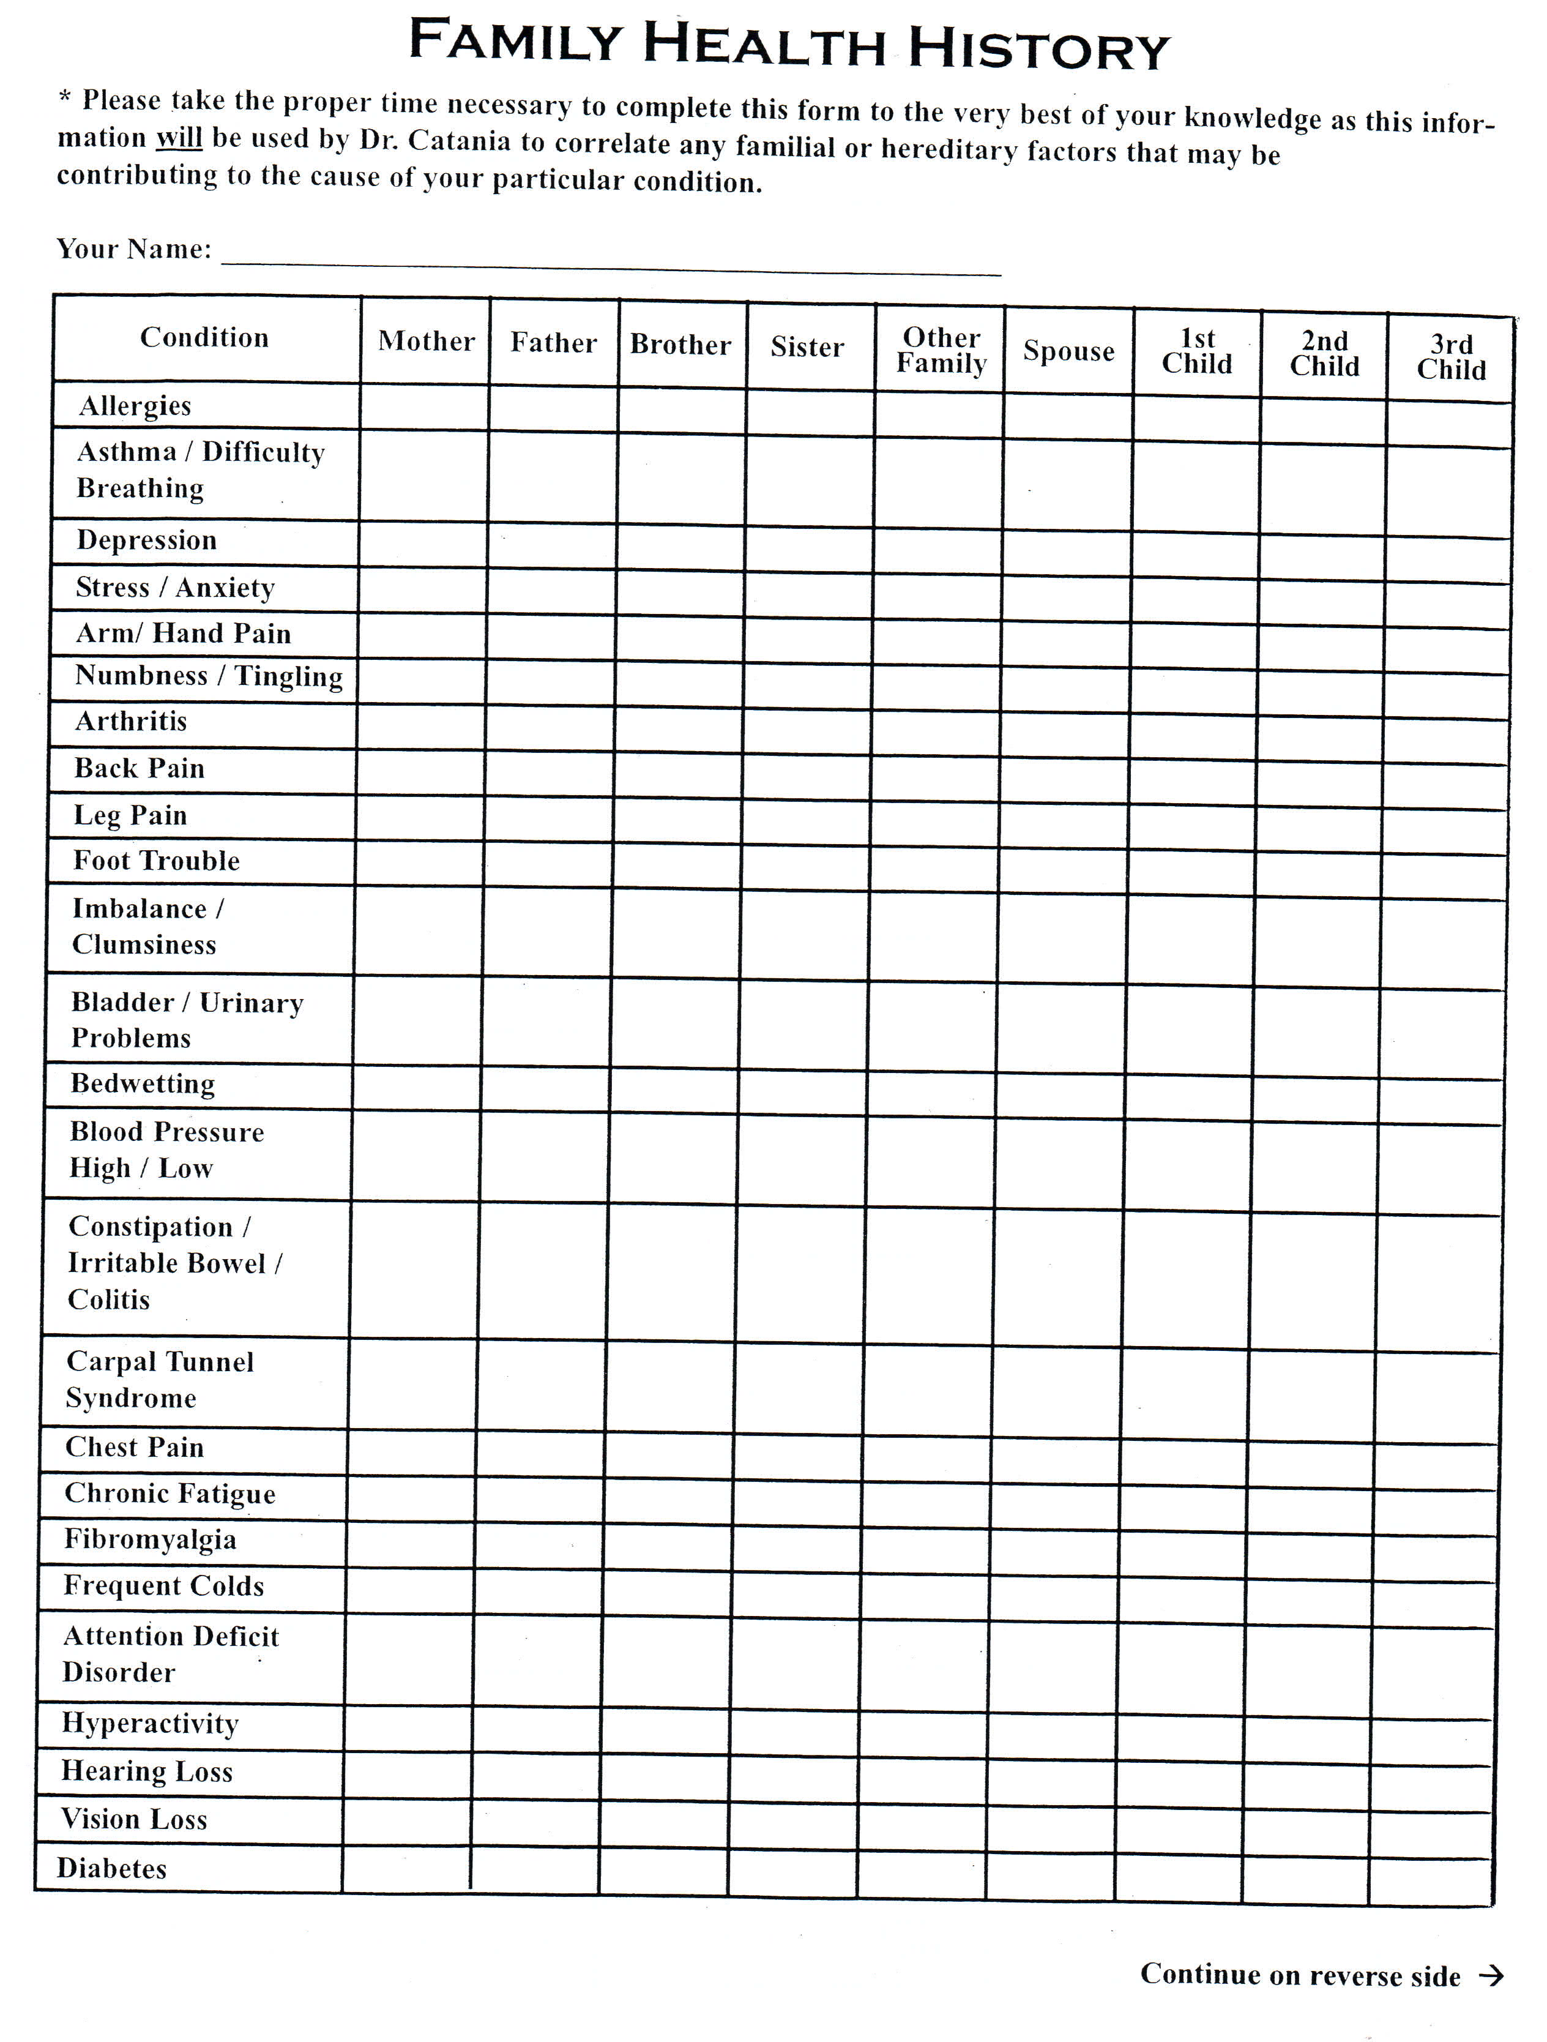
Dr. Paul Catania 320 Dundas St. Unit 6 London On N6B3R8